Getting Started
- If you do not have the MS Access program installed, you may need to install the 32-bit AccessDatabaseEngine:
https://download.microsoft.com/download/2/4/3/24375141-E08D-4803-AB0E-10F2E3A07AAA/AccessDatabaseEngine.exe
- All of your photos / documents must be installed in a location having a single root folder. I.e., the photos / documents must be installed on the same drive and they must have a common ancestor folder (the root folder).
- When PhotoDB opens, if it cannot find the database file, the following Options file will be presented (if not automatically displayed, select Options… from the File menu):

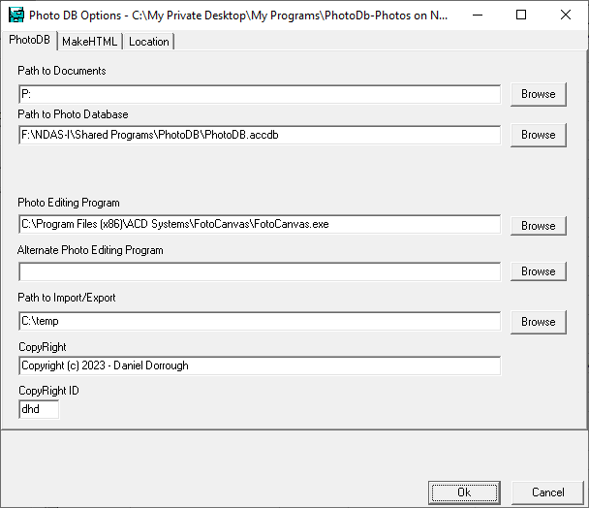

- Path to Documents: Browse to find the root folder where all of your photos and/or documents are located
- Path to Photo Database: Browse to find the photo database PhotoDB.accdb
- Photo Editing Program: Browse to find the program that you wish to use to edit photos (for example, FotoCanvas.exe or PhotoShop.exe.
- Alternate Photo Editing Program: If, for some reason, you want access to a 2nd photo editing program you can specify it here.
- CopyRight: Specify who the default copyright for all photos should be assigned to. Individual photos may be assigned to other individuals or organizations using the COPY_ID field in each record.
- Copyright ID: This is the default COPY_ID which will be assigned to each record in the database.

All of the above fields on the Options dialog should be filled in before continuing to use the PhotoDB program.

Note1: This information will be saved to PhotoDB.INI file in the same folder as the .EXE file for future reference.

Note2: This default .INI file can be overridden using a program parameter option (e.g. PhotoDB.exe {documents path}PhotoDB.INI}. This could be put into a batch (.BAT) file, for example.
- Once in the “Photos” folder, double-click on the “PhotoDB” application (this may be displayed as either “PhotoDB.exe” or just “PhotoDB”.

- The first time that you use the program, you might get this dialog:

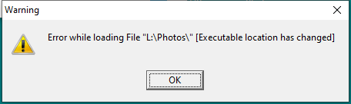
You can safely ignore it by clicking the “OK” button. The first time that you use PhotoDB, you may get a screen like this:

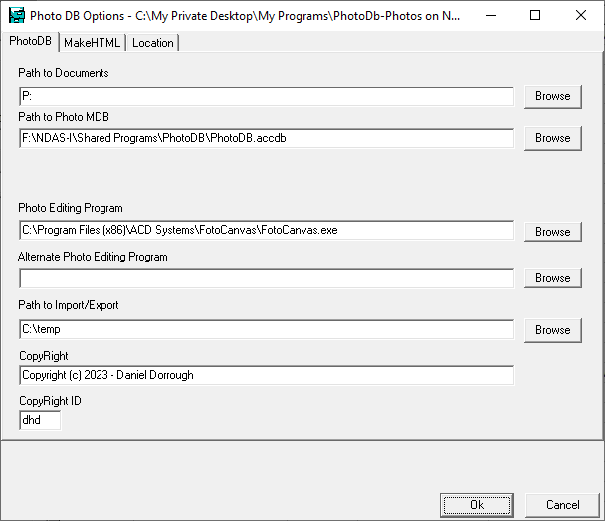
- Note: the above dialog is also accessible from the Options item in the File menu.
- At this point you should specify the path to the root folder which contains all of your photos and/or documents. This is the “Path to Documents”.
- You should also enter the full path and file name of the database which will be used to store the information about the photos and documents. This is the “Path to Photo Database”. It is ordinarily a Microsoft .ACCDB database named PhotoDB.ACCDB.
- You may also (optionally) enter the other items. This can also be done at a later time using the Options item of the File menu. When finished with this dialog, press the “OK” button.
- At this point, you may scan all of the photos and/or documents which are contained in the root folder (“Path to Documents”).
- To do this, select the “Scan for Photos/Documents…” item from the file menu.
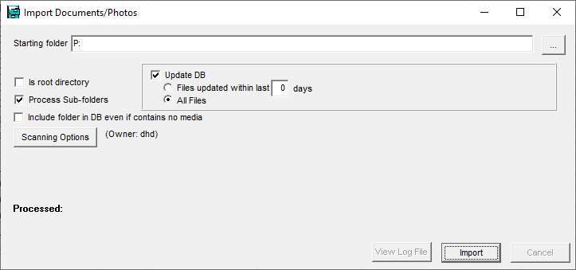
- Since the database is currently empty, you can leave the “Starting Folder” set to your root folder (taken from the previous options dialog “Path to Documents”).
- Since this is an initial scan you should check the “Is root directory” checkbox.
- Update DB should be checked unless you just wish to perform an initial test scan which will not update the database.
- When ready, click the “Import” button.
- You should then be presented with the “Scanning Options” dialog:
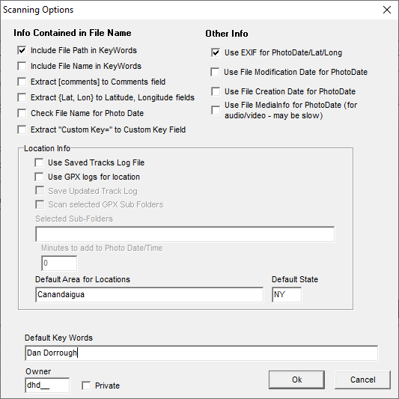
- At this point you should select all of the options you wish to use during the scan.
  - You might wish to check “Include File Path in Keywords” if your folder structure has meaningful path names.
  - Check “Include File Name in Keywords” if your photos / documents have meaningful names (rather than names like “IMG_9876.JPG”).
  - If the photos were taken with a digital camera which records the date/time in the meta data you should check “Use EXIF for PhotoDate/Lat/Lon”.
  - If videos were taken with a digital camera which records the date/time in the meta data you should check “Use File MediaInfo for PhotoDate (for audio/video - may be slow)”
  - Unless you have GPS data files (.GPX) corresponding to the dates and times that some or all photos / videos were taken, leave most of the “Location Info” fields unchanged.
  - If all of the photos / videos were taken in the same area or location, you may enter Default Area for Locations.
  - If all of the photos / videos were taken in the same state, you may enter Default State.
  - If all of the photos and documents should contain the same key words in database records enter a value in the “Default Key Words” field.
  - If all of the photos and/or videos were taken in the same state, you can enter the state code (i.e., “NY”) in the “Default State” field.
  - You can enter a 3-letter code to indicate who owns the photos into the Owner field.
- When you are ready, click the OK button and all of the photos and documents contained in or below the root folder will be scanned and added to the database.

Once you get into the PhotoDB program you should see this screen. This is the “Filter” screen of the PhotoDB program:

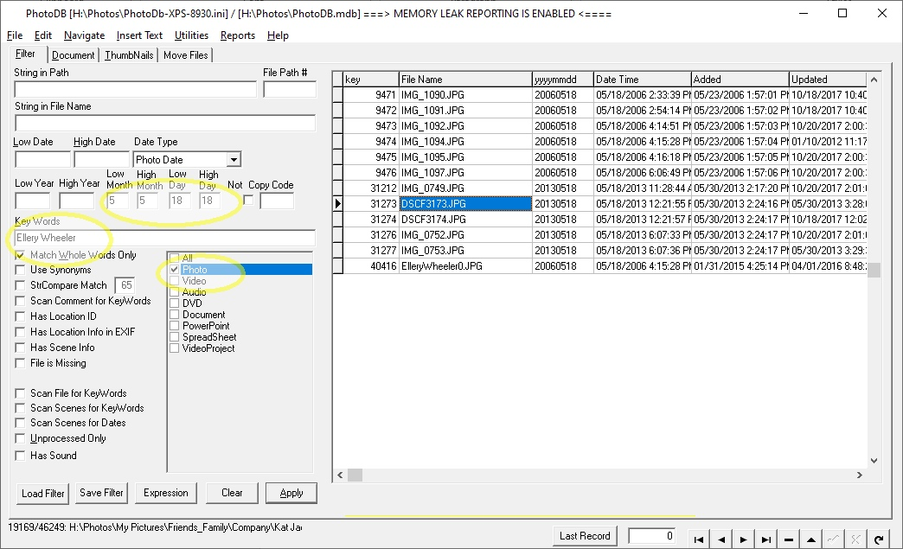

On this screen you specify a “filter” for the documents or photos that you want to find. On the above screen, the “Key Words” have been specified as “Ellery Wheeler”, the month has been specified as “5” and the day is specified as “18”. Once you press the “Apply” button, a list of all of the documents/photos that are found meeting the filter conditions will be displayed on the right side. In the above example, all of the photos that were taken on June 18, of any year, that include the keywords “Ellery Wheeler” are listed.

To select a specific document/photo, just click the desired line. Click on the document tab near the top. This will change to the “Document” page:

The “document” page displays information about the document, including:
- The path to the document
- The file name of the documents
- The year/month/day that the photo was taken (if known) or the date that the document was created
- The date that the record in the database was updated created and the date it was created.
- The location (latitude/longitude) associated with it (if any)
- A list of “key words” which may be used when searching for records.
- Any “comments” that are associated with the record. When searching/filtering records, “comments” are not usually included in the search. However, the “Scan Comments for Keywords” option on the “Filter” page can cause comments to be included in searches.

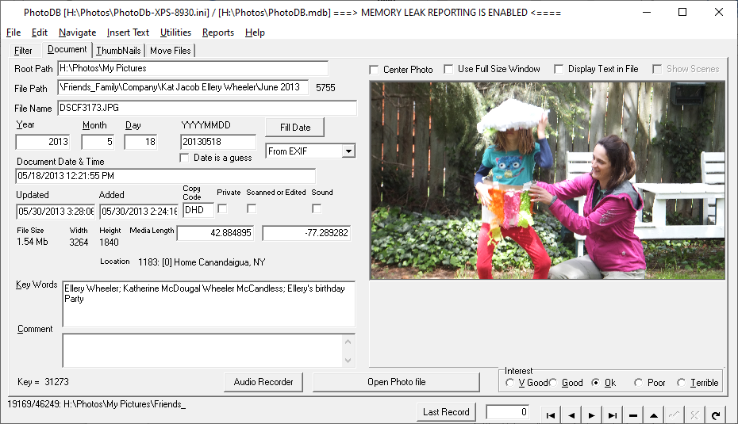

This “Getting Started” document only includes a tiny fraction of the database capabilities. For additional information, see the “PhotoDB User Manual.docx” file.

